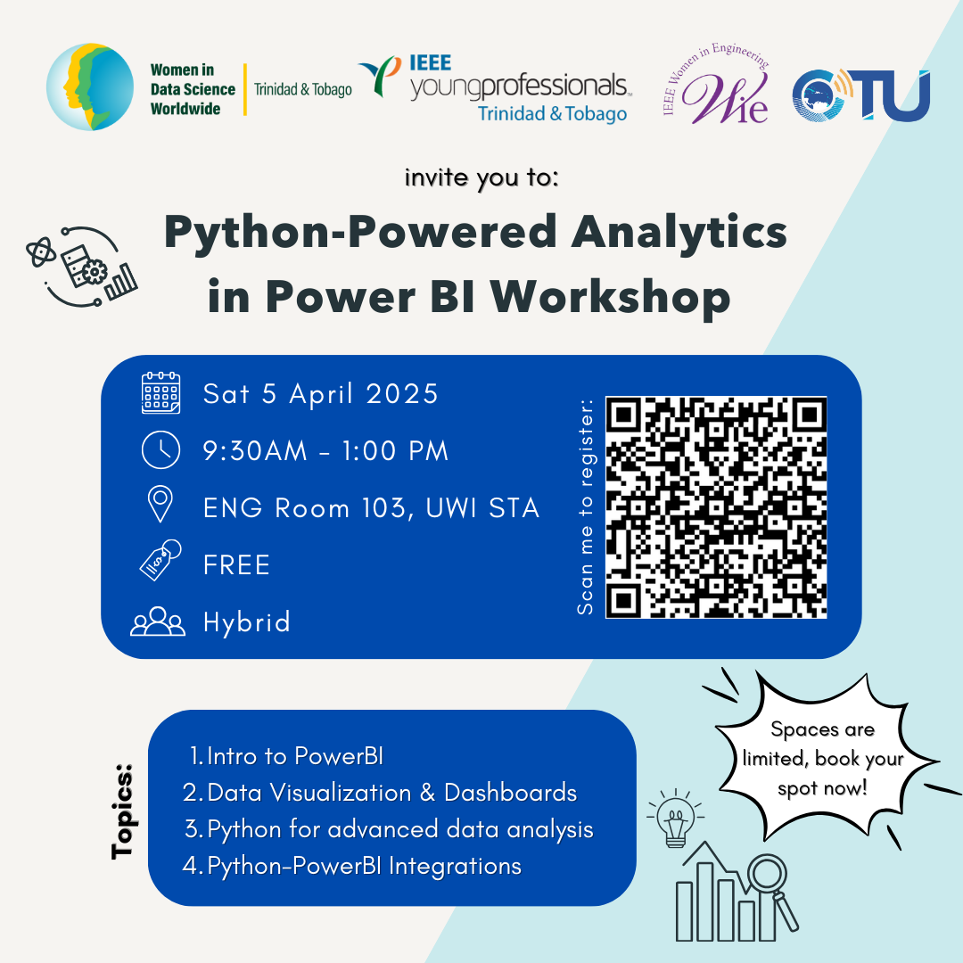

This hands-on workshop blends the power of Python with Power BI to take your data analysis skills to the next level. Whether you are a beginner or looking to sharpen your skills, you will walk away with practical knowledge you can apply immediately.

📘 **Learning Outcomes**

By the end of this workshop, you will be able to:

✔️ Navigate Power BI and create interactive dashboards with confidence.

✔️ Integrate Python into your Power BI workflows for advanced analytics.

✔️ Visualize data insights clearly and effectively to support better business decisions.

✔️ Automate and extend Power BI capabilities using Python-powered tools.

**Requirements**:

1. Computer Literacy (compulsory), Basic programming and problem-solving skills (recommended)

2. Laptop/Desktop with [**Power BI Desktop**](https://www.microsoft.com/en-us/power-platform/products/power-bi/desktop) and [**Python**](https://www.python.org/downloads/) installed

3. [Kaggle account](https://www.kaggle.com/) to access dataset (optional but highly *recommended*)

4. Access to the [**Workshop Folder**](https://drive.google.com/drive/folders/1LSjzDvlslWQ85eH6_UTuwfb6MGOp8v99?usp=drive_link)and [**Software Installation**](https://drive.google.com/file/d/12lAHMoZNvidnWZZ2KIFXGn4NA4DHBosQ/view?usp=drive_link).

**Workshop Agenda (Tentative)**

Prior to the workshop, feel free to view the [**Workshop Installation Sheet**](https://drive.google.com/file/d/12lAHMoZNvidnWZZ2KIFXGn4NA4DHBosQ/view?usp=drive_link)for required software (highly recommended).

| **Time (AST)** | **Item** | **Speaker** |
| --- | --- | --- |
| 09:00 | Registration (in-person participants) | N/A |
| 09:30 | Welcome Remarks | **Dr. Letetia Addison**, Ambassador, WiDS TT  **Mr. Tariq Mohammed**, Chair IEEE, YPTT  **Ms. Gabrielle Johnson**, Vice Chair, CIYN |
| 09:40 | Workshop Overview and [**Icebreaker Activity**](https://www.menti.com/alnvua6v23mc)**:** *Join at Menti.com and use code 7222 5216*  **Workshop Folder Link:** [**https://tinyurl.com/powerbipythonworkshop**](https://tinyurl.com/powerbipythonworkshop) | **Dr. Letetia Addison**, Ambassador, WiDS TT |
| 09:50 | **Training Sessions**  **Session 1** - Intro to Power BI  [**Presentation** **Slideshow**](https://www.canva.com/design/DAGjvVp2BFE/J4Yzv86wU8biq1pAnHhhkg/view?utm_content=DAGjvVp2BFE&utm_campaign=designshare&utm_medium=link2&utm_source=uniquelinks&utlId=hceb6d65a2b): [**https://tinyurl.com/powerbipythonslides**](https://tinyurl.com/powerbipythonslides) | **Mr. Adhir Soechit**, WIDS TT Mentor |
| 10:15  10:50  11:00  11:40 | **Session 2** - Data Visualization & Dashboards  ***Break (5 to 10 mins)***  **Session 3** - Python for Advanced Data Analysis  **Session 4** - Python-Power BI Integrations | **Mr. Adhir Soechit**, WIDS TT Mentor |
| 12:15 | Open Q&A  [**Workshop Feedback Form**](https://forms.gle/oRADWZpMsLt53Upb6) | Moderated by **Dr. Letetia Addison** |
| 12:50 | Feedback on Future Capacity Building and Events | **Mr. Ismaeel Hosein**, Community Outreach Manager, IEEE YPTT |
| 12:55 | Closing and Next Steps | **Dr. Letetia Addison**, Ambassador, WiDS TT  **Mr. Tariq Mohammed**, Chair IEEE, YPTT  **Ms. Gabrielle Johnson**, Vice Chair, CIYN |
| 13:00 | Group Photo, Lunch & Networking | TBD |

**Highly Recommended Online Resource Links:**

[Datacamp.com](http://datacamp.com) - online learning platform designed to help persons learn about data science, software and analytics in a fun and interactive way.

***Recommended Datacamp Chapters***: These chapters provide a preview to using Power BI and Python. Seethis video for more! [DataCamp 101: Getting Started with DataCamp](https://www.youtube.com/watch?v=oO2RFvpHjDg)

* [Power BI Courses for all levels](https://www.datacamp.com/category/power-bi?page=1) and [Power BI Cheatsheet](https://www.datacamp.com/cheat-sheet/power-bi-cheat-sheet)
* [Python Courses for all levels](https://www.datacamp.com/category/python?page=1) and [Python Cheatsheet for Beginners](https://www.datacamp.com/cheat-sheet/getting-started-with-python-cheat-sheet)

**Accessing data challenges and open datasets**

[Kaggle](https://www.kaggle.com/) - world's largest data science community with powerful tools and resources to help you achieve your data science goals. Bonus! See a starter activity [here](https://www.kaggle.com/competitions/titanic).

**Happy Learning!** 🙂

**🌟 Connect with Us on Social Media!**

Stay inspired, stay informed, and stay connected with the **WiDS TT** and our partner communities, **IEEE** and **CTN**!

**📍 WiDS Trinidad & Tobago (WiDS TT)**

🌐 Website: [widstt.com](https://widstt.com)  
📧 Email: [widsttgroup@gmail.com](mailto:widsttgroup@gmail.com)

📺 YouTube: [@widstt](https://www.youtube.com/@widstt)  
💼 LinkedIn: [linkedin.com/in/widstt](https://www.linkedin.com/in/widstt/)  
📘 Facebook: [facebook.com/WiDSTT](https://www.facebook.com/profile.php?id=61557189645707)  
📸 Instagram: [@widsttgroup](https://www.instagram.com/widsttgroup/)

**🤝 Partner Communities (IEEE Young Professionals TT (IEEE YP TT and Caribbean Telecommunications Union (CTN)).**

**💼 LinkedIn**  
🔗 [IEEE YP TT](https://www.linkedin.com/in/ieee-yptt/)  
🔗 [Caribbean Telecommunications Union](https://www.linkedin.com/in/caribbean-telecoms-union-330b17138/)

**📸 Instagram**  
@IEEE.YPTT

@CaribbeanTelecommunications